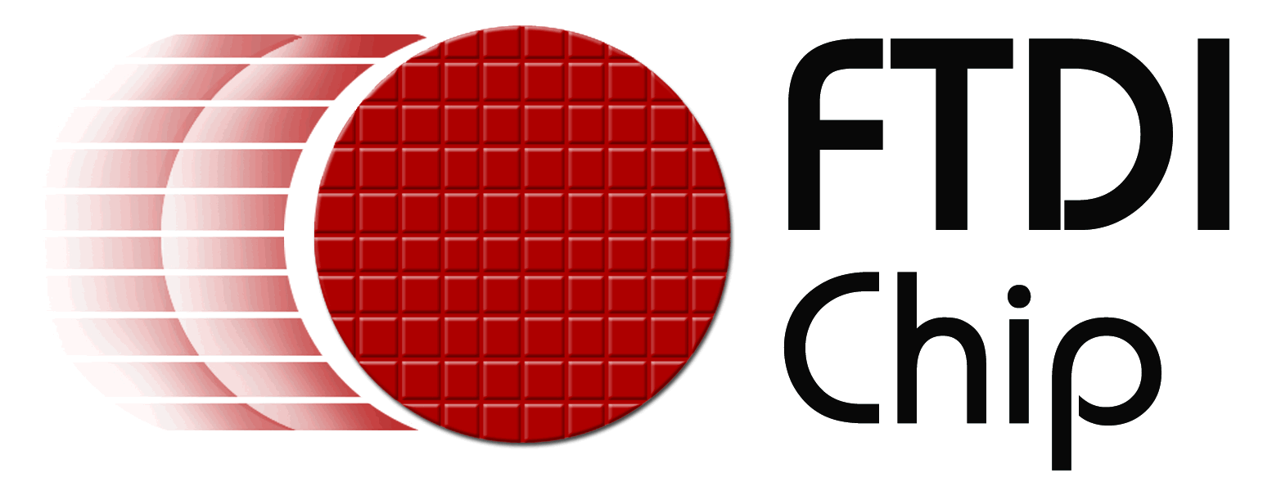

Company News

Reference: FTD0004
Date: February 2007

Parallax strengthens distribution agreement with FTDI Adds Vinculum USB host controller to product line-up
Hillsboro, Oregon – 14th February 2007, Future Technology Devices International Limited (FTDI) announces that Parallax Inc. has expanded its distribution agreement with the addition of the Vinculum Universal Serial Bus (USB) host controller IC to their product portfolio. Vinculum provides USB host capability to microcontroller-based products that previously did not have the hardware resources available. A wide range of consumer, commercial and industrial products can now incorporate USB connectivity with ease. Vinculum provides USB host interface and data transfer, and supports the most popular device classes. When interfacing to flash drives, Vinculum manages the file allocation table (FAT) structure by using a straightforward command set.
Jim Kenney, Sales Engineer, FTDI says, “We are delighted that Parallax has decided to extend their relationship with us by stocking and promoting our newest product, Vinculum. Parallax, one of our first North American distributors, continues to offer exceptional technical prowess and customer service.” Kenney continues, “Beyond distributing our ICs Parallax uses our products in 19 of their own exciting line of robots, educational kits and modules. They have been a long-term proponent of our technologies and an exciting partner to be involved with from the beginning. Chip and Ken Gracey, the founders of Parallax, run a unique and interesting high tech company that FTDI is proud to have as a key distribution partner for North America.” Ken Gracey says, “Parallax and our customers have a commitment to FTDI’s USB chips and the new Vinculum. Through each sale of our development boards we use an FTDI chip and introduce a customer to the hardware. The quality and consistency of the FTDI chips, along with solid operating system software drivers gives Parallax lots of confidence in recommending the product line to our customers.”
+++ends
For further information and reader enquiries:

Future Technology Devices International Ltd. 5285 NE Elam Young Parkway,
Suite B800 Hillsboro, OR 97124-6499

Tel: 503-547-0988 x 312 E-mail: jim.kenney@ftdichip.com
Fax: 503-547-0987 Web: www.ftdichip.com

Keith Dingwall, Future Technology Devices International Limited, 373 Scotland Street, Glasgow, G5 8QB. Scotland. UK

Tel: +44 (0) 141 429 2777 E-mail: keith.dingwall@ftdichip.com
Fax: +44 (0) 141 429 2758 Web: www.ftdichip.com

For further information, text and graphics by email or to discuss feature article opportunities:

Robert Huntley, Publitek Limited, 18 Brock Street, Bath, BA1 2LW, United Kingdom

Tel: +44 (0)1225 470 000 E-mail: robert.huntley@publitek.com
Fax: +44 (0)1225 470 047 Web: www.publitek.com

About FTDI

Future Technology Devices International (FTDI) specialise in the design and supply of silicon and software solutions for the Universal Serial Bus (USB). FTDI offer a simple route to USB migration by combining easy to implement IC devices with proven, ready to use, royalty-free USB firmware and driver software. The company’s single and multi-channel USB peripheral devices come with an easy to use UART or FIFO interface. These popular devices can be used in legacy USB to RS232/RS422 converter applications or to quickly interface an MCU, PLD, or FPGA to USB. A wide range of evaluation kits and modules are available to evaluate FTDI’s silicon prior to design-in.

Vinculum is FTDI’s brand name for a range of USB Host / Slave Controller ICs that provide easy implementation of USB host controller functionality within products, and utilise FTDI's tried and tested embedded firmware to significantly reduce development costs and time to market.

FTDI is a fabless semiconductor company headquartered in Glasgow, UK, and has regional offices in Oregon, USA, and Taipei, Taiwan. More information is available at http://www.ftdichip.com

About Parallax Inc.
Parallax, Inc. is a privately held company located in Rocklin, California. Parallax designs and manufactures microcontroller development tools and small single-board computers. Our current product line consists of BASIC Stamp® microcontrollers and development software, SX chips and programmers/debuggers, Propeller™ chips and tools, FTDI chips, project boards, robotics kits, educational tools, and sensors.

For more information about Parallax visit www.parallax.com.

