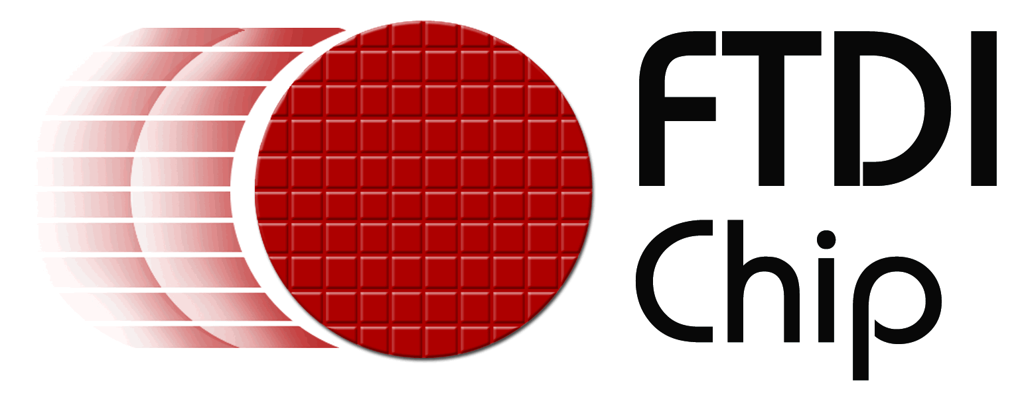

Product news

Reference: FTD0014
Date: 12th September 2007

FTDI’s virtual COM port drivers gain Microsoft Windows Vista certification
Glasgow, Scotland, 12th September 2007, Future Technology Devices International, (FTDI) announces the availability of Microsoft certified device drivers for the Windows Vista operating system. These drivers, having passed the strict Windows Hardware Quality Labs (WHQL) testing, are provided with a digitally signed certificate. These unified virtual COM port (VCP) and DLL direct interface (D2XX) drivers are available for FTDI’s range of serial to USB ICs, including the popular FT232R, FT232B and FT2232 devices.

The VCP drivers include enhancements that are specific to the Vista operating system model, including improved power management response that allows faster start-up and shutdown of devices.

With this recent addition, FTDI is able to provide Microsoft certified drivers for all current operating system releases. Both 32 and 64 bit operating systems are supported. The digital signed certificate embedded within the driver allows for auto installation of end-user software applications, meaning that no errors or security warnings are encountered during the installation process.

The drivers are available now, as a free download from FTDI’s web site. http://www.ftdichip.com/Drivers/VCP.htm
+++ends
For further information and reader enquiries:

Ruppel Joshi, Future Technology Devices International Limited, 373 Scotland Street, Glasgow, G5 8QB. Scotland. UK

Tel: +44 (0) 141 429 2777 E-mail: sales1@ftdichip.com
Fax: +44 (0) 141 429 2758 Web: www.ftdichip.com

Jim Kenney, Future Technology Devices International Ltd. 7235 NW Evergreen Parkway, Suite 600, Hillsboro, Oregon 97124-5803

Tel: 503-547-0988 E-mail: jim.kenney@ftdichip.com
Fax: 503-547-0987 Web: www.ftdichip.com

For further information, text and graphics by email or to discuss feature article opportunities:

Robert Huntley, Publitek Limited, 18 Brock Street, Bath, BA1 2LW, United Kingdom

Tel: +44 (0)1225 470 000 E-mail: robert.huntley@publitek.com
Fax: +44 (0)1225 470 047 Web: www.publitek.com

About FTDI

Future Technology Devices International (FTDI) specialise in the design and supply of silicon and software solutions for the Universal Serial Bus (USB). FTDI offer a simple route to USB migration by combining easy to implement IC devices with proven, ready to use, royalty-free USB firmware and driver software. The company’s single and multi-channel USB peripheral devices come with an easy to use UART or FIFO interface. These popular devices can be used in legacy USB to RS232/RS422 converter applications or to quickly interface an MCU, PLD, or FPGA to USB. A wide range of evaluation kits and modules are available to evaluate FTDI’s silicon prior to design-in.

Vinculum is FTDI’s brand name for a range of USB Host / Slave Controller ICs that provide easy implementation of USB host controller functionality within products, and utilise FTDI's tried and tested embedded firmware to significantly reduce development costs and time to market.

FTDI is a fabless semiconductor company headquartered in Glasgow, UK, and has regional offices in Oregon, USA, and Taipei, Taiwan. More information is available at http://www.ftdichip.com

