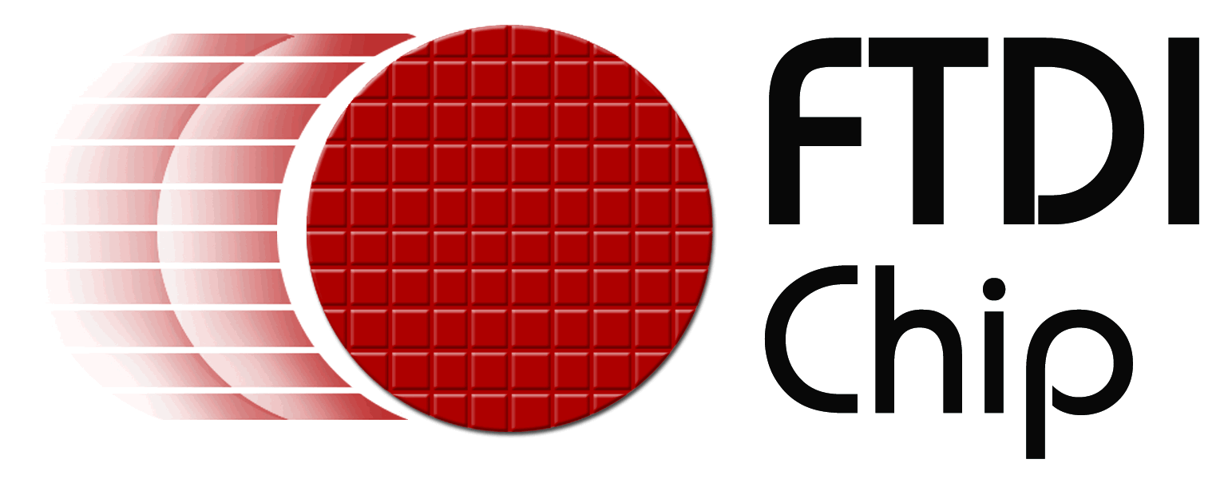

Product news

Reference: FTD0021
Date: April 2008

FTDI first vendor to release Microsoft certified USB-UART driver for Windows Server 2008
2nd April 2008, Future Technology Devices International Limited (FTDI) today announced the availability of its latest Microsoft certified CDM device driver for all Windows platforms, including Vista SP1 and the newly released Server 2008. The driver, having recently been certified by the Windows Hardware Quality Labs (WHQL), works with all FTDI’s USB to Serial interface ICs, including the popular FT232R, FT232B, FT245R, FT245B devices, as well as the dual channel FT2232 devices.
Using a unique driver architecture, the package supports both a standard COM port interface and a proprietary DLL interface. The driver also incorporates a digital signed certificate, embedded within it, that assists the automatic installation of end-user software applications.
It is available by free download, in a ZIP file or as a setup executable, from http://www.ftdichip.com/Drivers/VCP.htm
+++ends
For further information and reader enquiries:

Daniel McCaffery, Future Technology Devices International Limited, 373 Scotland Street, Glasgow, G5 8QB. Scotland. UK

Tel: +44 (0) 141 429 2777 E-mail: sales1@ftdichip.com
Fax: +44 (0) 141 429 2758 Web: www.ftdichip.com

Bob Recny, Future Technology Devices International Ltd. 7235 NW Evergreen Parkway, Suite 600, Hillsboro, Oregon 97124-5803

Tel: 503-547-0988 E-mail: bob.recny@ftdichip.com
Fax: 503-547-0987 Web: www.ftdichip.com

For further information, text and graphics by email or to discuss feature article opportunities:

Robert Huntley, Publitek Limited, 18 Brock Street, Bath, BA1 2LW, United Kingdom

Tel: +44 (0)1225 470 000 E-mail: robert.huntley@publitek.com
Fax: +44 (0)1225 470 047 Web: www.publitek.com

About FTDI

Future Technology Devices International (FTDI) specialise in the design and supply of silicon and software solutions for the Universal Serial Bus (USB). FTDI offer a simple route to USB migration by combining easy to implement IC devices with proven, ready to use, royalty-free USB firmware and driver software. The company’s single and multi-channel USB peripheral devices come with an easy to use UART or FIFO interface. These popular devices can be used in legacy USB to RS232/RS422 converter applications or to quickly interface an MCU, PLD, or FPGA to USB. A wide range of evaluation kits and modules are available to evaluate FTDI’s silicon prior to design-in.

Vinculum is FTDI’s brand name for a range of USB Host / Slave Controller ICs that provide easy implementation of USB host controller functionality within products, and utilise FTDI's tried and tested embedded firmware to significantly reduce development costs and time to market.

FTDI is a fabless semiconductor company headquartered in Glasgow, UK, and has regional offices in Oregon, USA, and Taipei, Taiwan. More information is available at http://www.ftdichip.com

