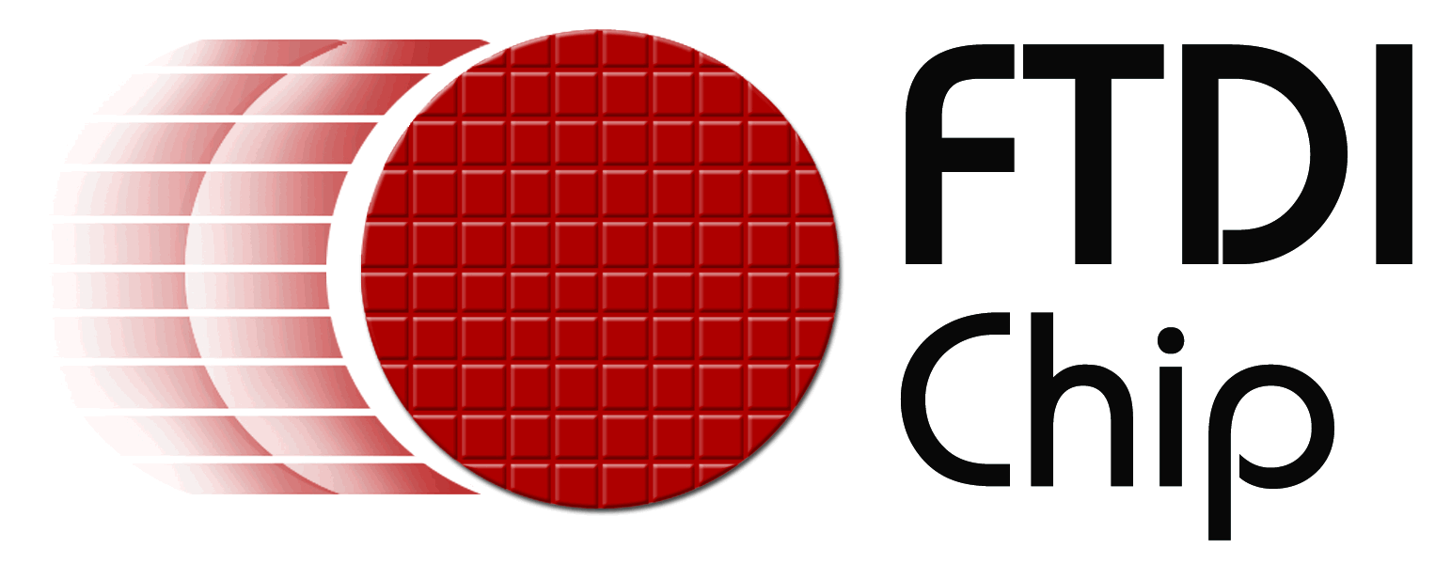

Company news

Reference: FTD0023
Date: May 2008

FTDI and Daito Electron present USB IC line-up at ESEC
Booth No: East 31-25
Embedded Systems Expo (ESEC), Tokyo, 14th May 2008. Future Technology Devices International Limited, FTDI, announces their attendance at ESEC with their distribution partner Daito Electron Company Limited.
On display will be the full FTDI product line-up, including legacy serial communication ICs (FT232R, FT245R, FT2232D) and the Vinculum VNC1L USB dual embedded host bridge IC. A range of supporting modules, evaluation kits and reference designs will also be available. Field-based application engineering and technical support staff from both organisations will be available at the booth.
Daito Electron has been FTDI’s distribution partner in Japan since October 2000. Together, they foresee a strong demand for FTDI’s product line-up across the region. Daito Electron recently added FTDI’s host bridge IC, Vinculum, to its catalog. The device, already established across North America and Asia, provides USB host capability to microcontroller-based products that previously did not have the hardware resources available.
+++ends
For further information and reader enquiries:

Daniel McCaffery, Future Technology Devices International Limited, 373 Scotland Street, Glasgow, G5 8QB. Scotland. UK

Tel: +44 (0) 141 429 2777 E-mail: sales1@ftdichip.com
Fax: +44 (0) 141 429 2758 Web: www.ftdichip.com

Steve Huang, Future Technology Devices International Limited, 4F, No 18-3, Sec. 6 Mincyuan East Road, Neihu District, Taipei 114, Taiwan
Tel: +886 2 8791 3570 E-mail: steve.huang@ftdichip.com
Fax: +886 2 8791 3576 Web: www.ftdichip.com

For further information, text and graphics by email or to discuss feature article opportunities:

Robert Huntley, Publitek Limited, 18 Brock Street, Bath, BA1 2LW, United Kingdom

Tel: +44 (0)1225 470 000 E-mail: robert.huntley@publitek.com
Fax: +44 (0)1225 470 047 Web: www.publitek.com

About FTDI

Future Technology Devices International (FTDI) specialise in the design and supply of silicon and software solutions for the Universal Serial Bus (USB). FTDI offer a simple route to USB migration by combining easy to implement IC devices with proven, ready to use, royalty-free USB firmware and driver software. The company’s single and multi-channel USB peripheral devices come with an easy to use UART or FIFO interface. These popular devices can be used in legacy USB to RS232/RS422 converter applications or to quickly interface an MCU, PLD, or FPGA to USB. A wide range of evaluation kits and modules are available to evaluate FTDI’s silicon prior to design-in.

Vinculum is FTDI’s brand name for a range of USB Host / Slave Controller ICs that provide easy implementation of USB host controller functionality within products, and utilise FTDI's tried and tested embedded firmware to significantly reduce development costs and time to market.

FTDI is a fabless semiconductor company headquartered in Glasgow, UK, and has regional offices in Oregon, USA, and Taipei, Taiwan. More information is available at http://www.ftdichip.com

