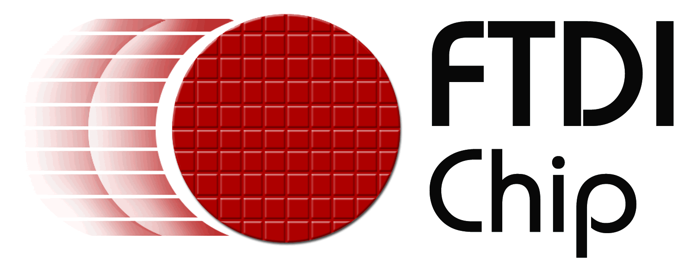

Product news

Reference: FTD0035
Date: 16th February 2009
Embedded World – Nuremberg – 3rd – 5th March 2009
Hall 12 Stand 442

Compact evaluation modules eases integration and development of USB 2.0 High Speed interfaces
Future Technology Devices International (FTDI) today announced the availability of two evaluation modules to support their recently announced FT2232H and FT4232H USB 2.0 High Speed devices, which have the capability of being configured in a variety of industry standard serial or parallel interfaces such as UART or FIFO. The module PCB measures just 36mm (L) x 30mm (W) x 12mm (H –including connector pins). Each module provides access to all the required signals through two 26 way (2 rows, 0.1” pitch) male headers measuring 32.9mm x 5.08mm. The pin length is 6mm.
The FT2232H_mini-module provides two independent configurable interfaces while the FT4232H_mini_module offers four such channels.

Aimed at system developers, the modules provide a convenient method of integrating a USB 2.0 High Speed interface to a number of asynchronous serial interfaces (UART, JTAG, I2C, SPI or customised serial interfaces) or parallel (FIFO) ports. Using a dual (FT2232H) or quad (FT4232H) device, the modules offer the ability to quickly evaluate, model or prototype systems that require USB 2.0 High Speed connectivity, while implementing the complete USB 2.0 protocol with no additional firmware required. There is no need for users to understand any low level USB 2.0 protocols.

Each module is implemented with the a highly integrated FTDI USB 2.0 High Speed device which includes a +1.8 V LDO regulator, an integrated power-on reset (POR) function and an on-chip clock multiplier PLL (12 MHz to 480 MHz). A USB mini-B type connector (socket) on the PCB provides easy USB connectivity.

Drivers for the modules are the same as those used for the FT4232H and FT2232H. These are available from the FTDI website indicated below.
+++ends
For further information and reader enquiries:

Daniel McCaffrey, Future Technology Devices International Limited, Unit 1, 2 Seaward Place, Centurion Business Park, Glasgow. G41 1HH

Tel: +44 (0) 141 429 2777 E-mail: sales1@ftdichip.com
Fax: +44 (0) 141 429 2758 Web: www.ftdichip.com

Russ Paine, Future Technology Devices International Ltd. 7235 NW Evergreen Parkway, Suite 600, Hillsboro, Oregon 97124-5803

Tel: +1 503-547-0988 E-mail: us.sales@ftdichip.com
Fax: +1 503-547-0987 Web: www.ftdichip.com

Alex Chiang, Future Technology Devices International Limited (Taiwan), 2f, No.516, Sec.1, NeiHu Road, NeiHu District, Taipei 114, Taiwan
Tel : +886 2 8797 1330 E-mail: tw.sales1@ftdichip.com
Fax: +886 2 8751 9737 Web: www.ftdichip.com

Jeff Wang, Future Technology Devices International Limited (China)
Room 408, 317 Xianxia Road, Changning District, Shanghai, 200051, P. R. China
Tel: +86 21 6235 1596 E-mail: cn.sales@ftdichip.com
Fax: +86 21 6235 1595 Web: www.ftdichip.com

For further information, text and graphics by email or to discuss feature article opportunities:

Robert Huntley, Publitek Limited, 18 Brock Street, Bath, BA1 2LW, United Kingdom

Tel: +44 (0)1225 470 000 E-mail: robert.huntley@publitek.com
Fax: +44 (0)1225 470 047 Web: www.publitek.com

About FTDI

Future Technology Devices International (FTDI) specialise in the design and supply of silicon and software solutions for the Universal Serial Bus (USB). FTDI offer a simple route to USB migration by combining easy to implement IC devices with proven, ready to use, royalty-free USB firmware and driver software. The company’s single and multi-channel USB peripheral devices come with an easy to use UART or FIFO interface. These popular devices can be used in legacy USB to RS232/RS422 converter applications or to quickly interface an MCU, PLD, or FPGA to USB. A wide range of evaluation kits and modules are available to evaluate FTDI’s silicon prior to design-in.

Vinculum is FTDI’s brand name for a range of USB Host / Slave Controller ICs that provide easy implementation of USB host controller functionality within products, and utilise FTDI's tried and tested embedded firmware to significantly reduce development costs and time to market.

FTDI is a fabless semiconductor company headquartered in Glasgow, UK, and has regional offices in Oregon, USA, and Taipei, Taiwan. More information is available at http://www.ftdichip.com

