

Product news

Reference: FTD0042
Date: March 2010

Embedded World, March 2 – 4th, Nuremberg, Germany
Hall 12 - 234

Programmable dual USB 2.0 host/slave SOC assists in lowering design component count and reduces costs.
March 2nd 2010, Embedded World, Nuremberg – Future Technology Devices International (FTDI) today announced the launch of their Vinculum VNC2 user programmable dual USB 2.0 Host/Slave intelligent SOC controller.
Building on FTDIs competitive advantage of fully supporting designers and customers by delivering a complete solution, VNC2 enhances the initial member of the Vinculum family, the VNC1L, by reducing the device cost as well as introducing the capability for designers to develop their own application firmware and programme the host controller themselves.
VNC2 comes with a royalty free software development environment – the Integrated Design Environment (IDE) which includes a compiler, linker and debugger to fully utilise the increased memory and multitude of communication protocols handled by VNC2. The software developed toolkit is based on the ‘C’ language and provides a comprehensive suite of object files to provide support for USB host functionality including USB Flash Drive (B.O.M.S.) storage, HID, USB COMMs class and FAT File functionality.
VNC2 includes a new, customised 16bit MCU core, 256kB on chip programmable e-Flash program memory and 16kB of SRAM data memory. The IO communication capability has been enhanced to include 2 SPI slave controllers, 1 SPI master controller, 1 high speed UART interface (up to 3M baud ) plus a flexible 8 channel PWM block allowing precise 16-bit control of motors, servos and other analog application areas. In addition to these enhancements, VNC2’s 1-Pin debugger interface, which functions independently of the MCU core, provides a simple yet sophisticated debugging / device programming interface. All this at a substantially lower cost than it predecessor.
VNC2 launches in 3 different pin-count sizes, 32LD, 48LD and 64LD supporting up to 44 user defined IO pins. Each pin-count size is available in LQFP or the more compact QFN package option - 6 variants in total. The 48LD LQFP version, offers a “close-fit” equivalent pin-out to the current VNC1L allowing easy system upgrades to the new VNC2, often with just a simple BOM change.
Operating from a single +3.3 VDC supply, the VNC2 has a low standby current of typically 128uA and also has 3 low power modes.
The Vinculum VNC2 suits a broad range of USB consumer and industrial related applications including camera, mobile accessories, data loggers, toys, keyboards, game controller interfacing, POS applications and USB to USB bridges.
Engineering samples of VNC2 are now available with mass production expected from May 2010. For 10,000+ quantities the VNC2 48-pin LQFP is priced at US$2.75.
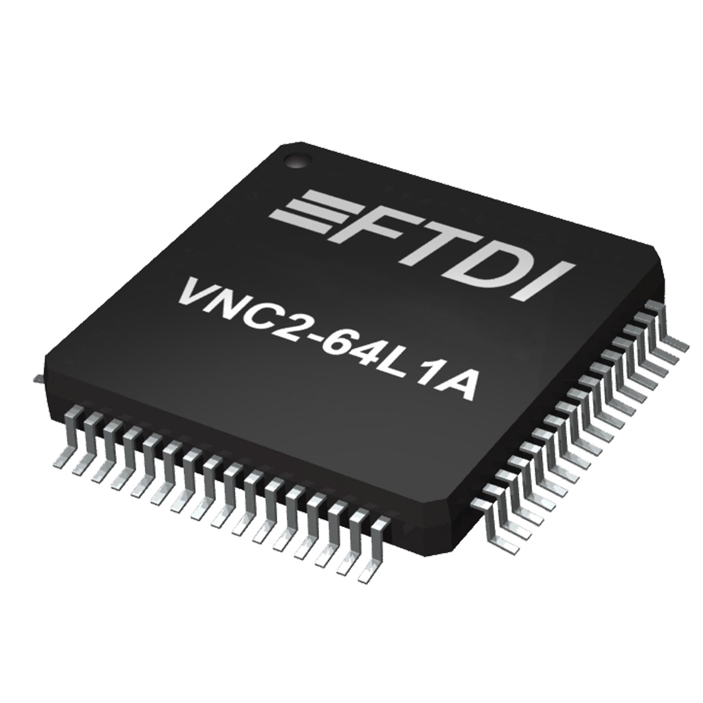
Download 2 graphics here:
ftp://ftp.publitek.com/pub/PressPhotos/FTD0042-64L-image-2.jpg

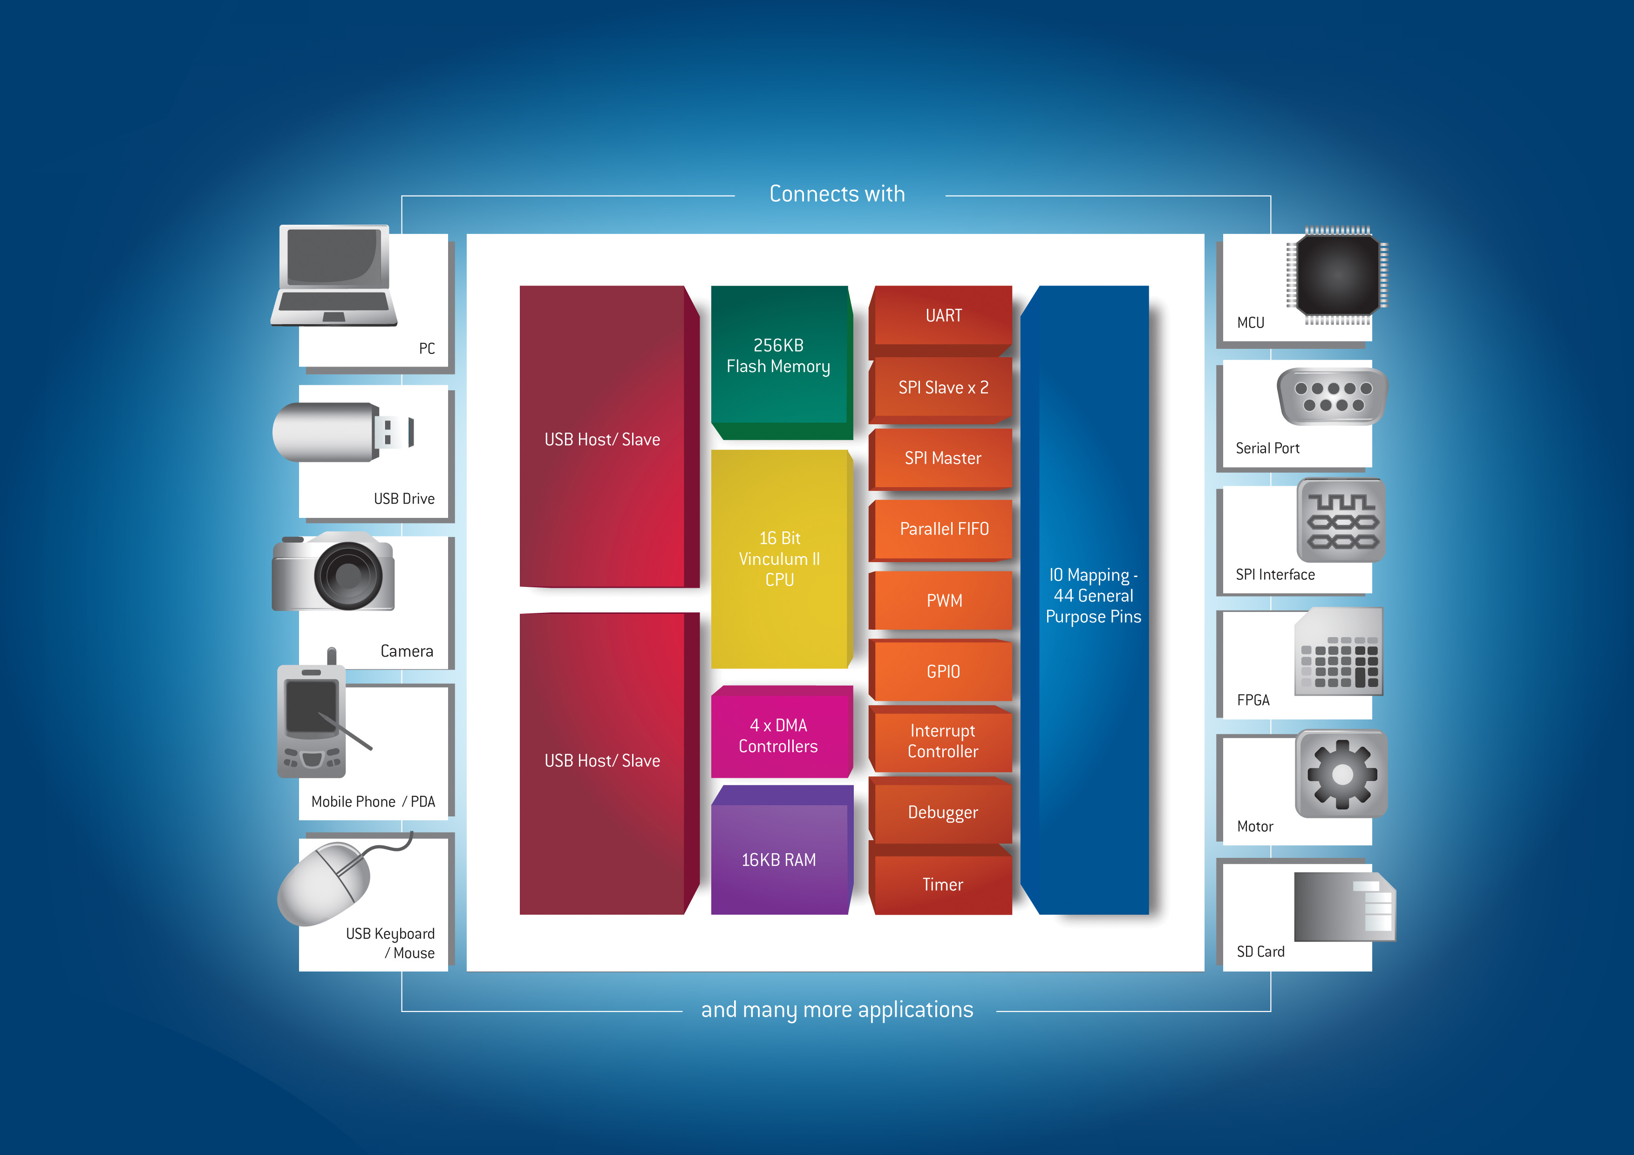
ftp://ftp.publitek.com/pub/PressPhotos/FTD0042-VNC2 BlockDiagram-A4.jpg

For further information and reader enquiries:

Daniel McCaffrey, Future Technology Devices International Limited, Unit 1, 2 Seaward Place, Centurion Business Park, Glasgow. G41 1HH

Tel: +44 (0) 141 429 2777 E-mail: sales1@ftdichip.com
Fax: +44 (0) 141 429 2758 Web: www.ftdichip.com

Damon Barsuglia, Future Technology Devices International Ltd. 7235 NW Evergreen Parkway, Suite 600, Hillsboro, Oregon 97124-5803

Tel: +1 503-547-0988 E-mail: us.sales@ftdichip.com
Fax: +1 503-547-0987 Web: www.ftdichip.com

Alex Chiang, Future Technology Devices International Limited (Taiwan), 2f, No.516, Sec.1, NeiHu Road, NeiHu District, Taipei 114, Taiwan
Tel : +886 2 8797 1330 E-mail: tw.sales1@ftdichip.com
Fax: +886 2 8751 9737 Web: www.ftdichip.com

Alex Chiang, Future Technology Devices International Limited (China)
Room 408, 317 Xianxia Road, Changning District, Shanghai, 200051, P. R. China
Tel: +86 21 6235 1596 E-mail: cn.sales@ftdichip.com
Fax: +86 21 6235 1595 Web: www.ftdichip.com

For further information, text and graphics by email or to discuss feature article opportunities:

Robert Huntley, Publitek Limited, 18 Brock Street, Bath, BA1 2LW, United Kingdom

Tel: +44 (0)1225 470 000 E-mail: robert.huntley@publitek.com
Fax: +44 (0)1225 470 047 Web: www.publitek.com

About FTDI

Future Technology Devices International (FTDI) specialise in the design and supply of silicon and software solutions for the Universal Serial Bus (USB). FTDI offer a simple route to USB migration by combining easy to implement IC devices with proven, ready to use, royalty-free USB firmware and driver software. The company’s single and multi-channel USB peripheral devices come with an easy to use UART or FIFO interface. These popular devices can be used in legacy USB to RS232/RS422 converter applications or to quickly interface an MCU, PLD, or FPGA to USB. A wide range of evaluation kits and modules are available to evaluate FTDI’s silicon prior to design-in.

Vinculum is FTDI’s brand name for a range of USB Host / Slave Controller ICs that provide easy implementation of USB host controller functionality within products, and utilise FTDI's tried and tested embedded firmware to significantly reduce development costs and time to market.

FTDI is a fabless semiconductor company headquartered in Glasgow, UK, and has regional offices in Oregon, USA, Shanghai, China and Taipei, Taiwan. More information is available at http://www.ftdichip.com

