
Embedded World - Hall 12.0 , Stand 12-234

Single Channel Hi-Speed USB to UART/FIFO Interface IC for Next Generation Peripheral Design
With the ability to be placed in various serial & parallel I/O configurations, including a proprietary dynamic bi-directional data bus
Future Technology Devices International Limited (FTDI) has further strengthened its portfolio of USB interface IC products with the release of the FT232H USB2.0 Hi-Speed device. This versatile single channel USB to UART/FIFO interface device can be configured via EEPROM to use a variety of different serial or parallel interfaces. Bundled with FTDI's well established and proven USB device drivers, this solution enables engineers to easily add Hi-Speed USB connectivity into new and legacy peripheral designs with a minimum of design and support effort. In addition, the associated UM232H evaluation module allows engineers to quickly prototype and tests the FT232H’s suitability for incorporation into new system designs. This highly integrated USB device controller contains USB, serial and parallel protocol engines, eliminating any requirement for USB specific firmware development. The device supports IO interface levels of 3.3V with 5V tolerant inputs, making it suitable for connection to a wide variety of logic, MPUs and FPGAs.
As well as supporting asynchronous serial (UART) interfacing, the FT232H also supports interface to many synchronous IOs such as SPI, I²C, JTAG, and FPGA programming interfaces, via its inbuilt Multi-Protocol Synchronous Serial Engine (MPSSE), which is capable of communication speeds of up to 30Mbits/s. In addition, MPSSE can be utilised by design engineers to implement their own synchronous serial bus protocols.
Incorporated as an interface option into the FT232H, is the new FT1248 bus - a proprietary, synchronous, half-duplex serial/parallel interface capable of communicating with external logic at data rates of up to 30Mbytes/s. The unusual feature of the FT1248 bus is its ability to trade off bandwidth against the number of physical data lines (one, two, four or eight) available to connect the FT232H to external logic, thus providing optimum flexibility to the system designer.
Integrated 1.8V and 3.3V low drop-out (LDO) voltage regulators reduce external component requirements, whilst the generous 1 Kbyte transmitter and receiver data buffers coupled with USB2.0 Hi-Speed technology offer greatly improved data throughput and reduced latency response times compared to existing USB2.0 compliant full speed products. Royalty free drivers for Windows, Linux, MAC and WinCE operating systems are available to download from the FTDI website.
Package options for the FT232H are 48 pin LQFP (FT232HL) or 48 pin QFN (FT232HQ) Pb-free packages. Both FT232H variants have an operational temperature range of -40⁰C to +85⁰C. FT232HL devices are priced at US$2.75 (for 1,000 pcs) whilst FT232HQ devices are priced at US$2.60 (for 1000 pcs). The UM232H customer evaluation module enables rapid prototyping / testing of the FT232H platform and connects to a standard 0.6” wide, 28 pin DIP socket. UM232H modules are priced at US$20 each (for 1 to 9 pcs).
FT232H IC datasheet is available for download:
http://www.ftdichip.com/Support/Documents/DataSheets/ICs/DS_FT232H.pdf
UM232H Module datasheet is available for download:
http://www.ftdichip.com/Support/Documents/DataSheets/Modules/DS_UM232H.pdf
Press images are available for download:
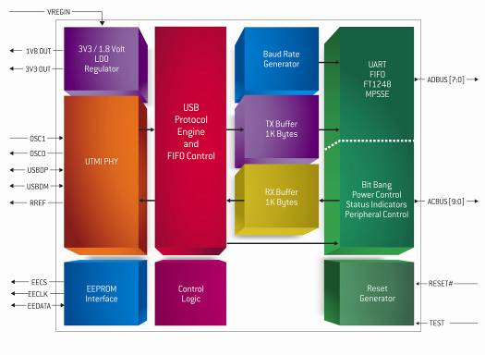
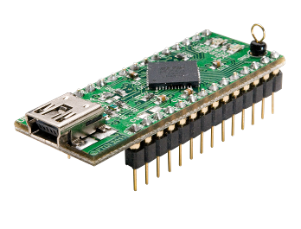
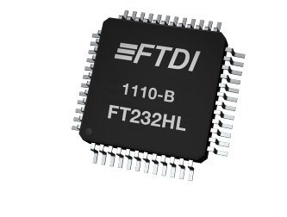
http://www.ftdichip.com/Corporate/FTPress.htm

About FTDI
Future Technology Devices International (FTDI) specialises in the design and supply of silicon and software solutions for the Universal Serial Bus (USB). FTDI offers a simple route to USB migration by combining easy-to-implement IC devices with proven, ready-to-use, royalty-free USB firmware and driver software. The company’s single and multi-channel USB peripheral devices come with an easy-to-use UART or FIFO interface. These popular devices can be used in legacy USB-to-RS232/RS422 converter applications or to quickly interface an MCU, PLD, or FPGA to USB. A wide range of evaluation kits and modules are available to evaluate FTDI’s silicon prior to design-in. Vinculum is FTDI’s brand name for a range of USB Host/Slave controller ICs that provide easy implementation of USB Host controller functionality within products and use FTDI's tried and tested firmware to significantly reduce development costs and time to market. FTDI is a fables semiconductor company headquartered in Glasgow, UK with R&D centres in Glasgow and Singapore and has regional sales offices in Oregon, USA, Shanghai, China and Taipei, Taiwan.
More information is available at http://www.ftdichip.com
Regional sales offices and distributor lists are available http://www.ftdichip.com/FTSalesNetwork.htm

For further information and reader enquiries:
Erika Leishman
Future Technology Devices International Limited
Unit 1, 2 Seaward Place, Centurion Business Park, Glasgow, G41 1HH, UK
Tel: +44 (0) 141 429 2777 Fax: +44 (0) 141 429 2758 E-mail: erika.leishman@ftdichip.com

Issued by:
Mike Green
Pinnacle Marketing Communications Ltd
Prosperity House, Dawlish Drive, Pinner, Middsx, HA5 5LN
Tel: +44 (0)20 84296543 E-mail: m.green@pinnaclemarcom.com Web: www.pinnacle-marketing.com

Ref: FTDIPR4 FT232H

