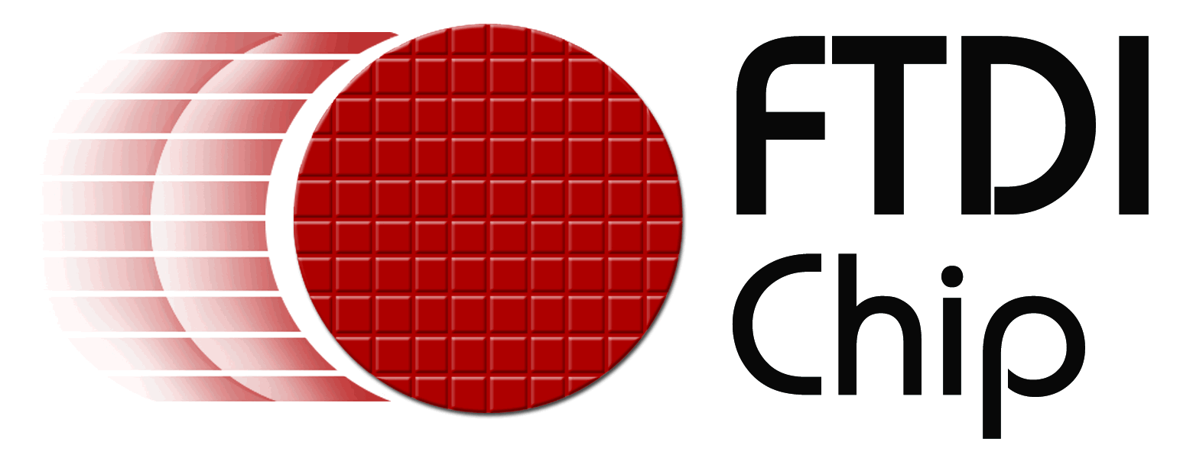
Embedded World - Hall 12.0 , Stand 12-234

用于新一代外设设计的
单通道高速USB转UART/FIFO接口芯片
能够用于各种串行和并行I/O配置,
包含专有动态双向数据总线
随着FT232H USB2.0高速芯片的发布，英商飞特蒂亚公司(FTDI)进一步巩固了其在USB接口集成电路产品的地位。此款多功能的单通道USB转UART/FIFO接口设备可通过EEPROM配置为各种不同的串行或并行接口。与FTDI建设完备精良的USB设备驱动一起，这套方案使工程师可以轻松的将高速 USB连接引入新的和传统的外设设计中。另外，还有相关的UM232H评估模块帮助工程师快速建立设计样机，测试FT232H集成到新的系统设计的适用性。其高度集成的USB设备控制器包含USB， 串行和并行协议引擎，而不需要开发USB专用固件。设备支持3.3V的IO接口电平，允许5V输入，使之适用于连接各种逻辑，MPU和FPGA。
FT232H不仅支持异步串行接口（UART），还通过其内建的多协议同步串行引擎（MPSSE）支持许多同步IO接口，比如SPI， I²C，JTAG以及FPGA编程接口，MPSSE通信速度能够达到30M比特/秒。另外，MPSSE可用于执行设计工程师自己的同步串行总线协议。
新的FT1248 总线是FT232H集成的一个接口功能，为专有的同步半双工串行/并行接口，与外部逻辑通信速率可以达到30M Byte/秒。FT1248 总线独特之处在于能够根据可用物理数据总线的数量（1，2，4或8）调整FT232H与外部逻辑连接的带宽， 从而为系统设计提供最优的适应性。
集成的1.8V和3.3V低压差稳压器减少了所需外部元件，同时与现有的USB2.0兼容的全速产品相比较而言，1 K字节大的收发数据缓存加上USB2.0高速技术大大改善了数据吞吐量， 缩减了延迟响应时间。FTDI网站可下载用于Windows, Linux, MAC 和 WinCE操作系统的免税驱动。
FT232H的封装选择有48针LQFP（FT232HL）或48针QFN（FT232HQ）无铅封装。这两种FT232H工作范围是-40⁰C ~ +85⁰C。FT232HL定价为$2.75（1,000片以上），FT232HQ定价为$2.60（1000片以上）。UM232H用户评估模块有助于快速建立原型或测试FT232H平台，与一个标准的0.6英寸宽，28针的DIP插座连接。UM232H模块单价定为$20（1~9片）。
FT232H IC datasheet is available for download:
http://www.ftdichip.com/Support/Documents/DataSheets/ICs/DS_FT232H.pdf
UM232H Module datasheet is available for download:
http://www.ftdichip.com/Support/Documents/DataSheets/Modules/DS_UM232H.pdf
Press images are available for download:
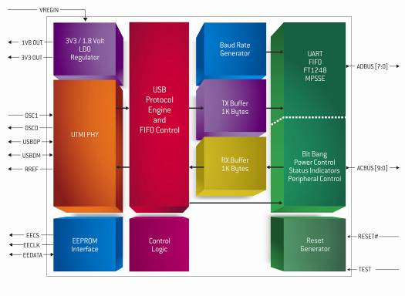
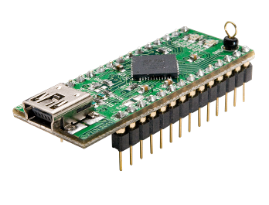
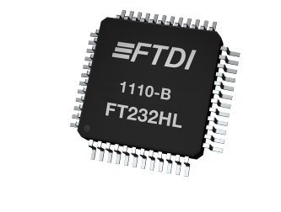
http://www.ftdichip.com/Corporate/FTPress.htm

About FTDI
Future Technology Devices International (FTDI) specialises in the design and supply of silicon and software solutions for the Universal Serial Bus (USB). FTDI offers a simple route to USB migration by combining easy-to-implement IC devices with proven, ready-to-use, royalty-free USB firmware and driver software. The company’s single and multi-channel USB peripheral devices come with an easy-to-use UART or FIFO interface. These popular devices can be used in legacy USB-to-RS232/RS422 converter applications or to quickly interface an MCU, PLD, or FPGA to USB. A wide range of evaluation kits and modules are available to evaluate FTDI’s silicon prior to design-in. Vinculum is FTDI’s brand name for a range of USB Host/Slave controller ICs that provide easy implementation of USB Host controller functionality within products and use FTDI's tried and tested firmware to significantly reduce development costs and time to market. FTDI is a fables semiconductor company headquartered in Glasgow, UK with R&D centres in Glasgow and Singapore and has regional sales offices in Oregon, USA, Shanghai, China and Taipei, Taiwan.
More information is available at http://www.ftdichip.com
Regional sales offices and distributor lists are available http://www.ftdichip.com/FTSalesNetwork.htm

For further information and reader enquiries:
Erika Leishman
Future Technology Devices International Limited
Unit 1, 2 Seaward Place, Centurion Business Park, Glasgow, G41 1HH, UK
Tel: +44 (0) 141 429 2777 Fax: +44 (0) 141 429 2758 E-mail: erika.leishman@ftdichip.com

Issued by:
Mike Green
Pinnacle Marketing Communications Ltd
Prosperity House, Dawlish Drive, Pinner, Middsx, HA5 5LN
Tel: +44 (0)20 84296543 E-mail: m.green@pinnaclemarcom.com Web: www.pinnacle-marketing.com

Ref: FTDIPR4 FT232H

