
Embedded World - Hall 12.0 , Stand 12-234

用於新一代外接設計的
單通道高速USB轉UART/FIFO介面晶片
能夠用於各種串列和並列I/O配置,
包含專有動態雙向數據匯流排
隨著FT232H USB2.0高速晶片的發布，英商飛特帝亞公司(FTDI)進一步鞏固了其在USB介面積體電路產品的地位。此款多功能的單通道USB轉UART/FIFO介面設備可透過EEPROM配置為各種不同的串列或並列介面，通過FTDI高效能的USB驅動，使這套方案讓工程師可以輕鬆的將高速 USB連接引入新的或傳統的外接設計中。另外，還有相關的UM232H開發模組幫助工程師快速設計樣品，測試FT232H以整合到新的系統設計。其高度集成的USB設備控制單元包含USB，串列和並列協議引擎，而不需要開發USB專用軔體。設備支援3.3V的IO介面電位，允許5V輸入，適用於連接各種邏輯，MPU和FPGA。
FT232H不僅支援非同步串列介面（UART），還透過其內建的多重協議同步串列引擎（MPSSE）支援許多同步IO介面，比如SPI， I2C，JTAG以及FPGA介面，MPSSE通信速度能夠達到30Mbit/秒。另外，MPSSE可用於執行設計工程師自己的同步串列匯流排協議。
新的FT1248 匯流排是FT232H集成的一個介面功能，為專有的同步半雙工串列/並列介面，與外部邏輯通信速率可以達到30Mbytes/秒。FT1248 匯流排獨特之處在於能夠根據可用物理數據匯流排的寬度（1，2，4或8）調整FT232H與外部邏輯連接的頻寬， 從而為系統設計提供最優的適應性。
內建的1.8V和3.3V低壓差穩壓器減少了所需外部元件，同時與現有的USB2.0兼容的全速產品相比較而言，1 K位元組大的收發數據暫存器加上USB2.0高速技術大大改善了數據傳輸效能， 縮減了延遲回應時間。FTDI網站可下載用於Windows, Linux, MAC 和 WinCE作業系統的免費驅動。
FT232H的封裝選擇有48腳LQFP（FT232HL）或48腳QFN（FT232HQ）無鉛封裝。這兩種FT232H工作範圍是-40度C ~ +85度C。FT232HL定價為$2.75（1,000片以上），FT232HQ定價為$2.60（1000片以上）。UM232H用戶開發模組有助於快速建立原型或測試FT232H平台，與一個標準的0.6英寸寬，28針的DIP插座連接。UM232H模組單價定為$20（1~9片）。

FT232H IC datasheet is available for download:
http://www.ftdichip.com/Support/Documents/DataSheets/ICs/DS_FT232H.pdf

UM232H Module datasheet is available for download:
http://www.ftdichip.com/Support/Documents/DataSheets/Modules/DS_UM232H.pdf
Press images are available for download:
http://www.ftdichip.com/Corporate/FTPress.htm

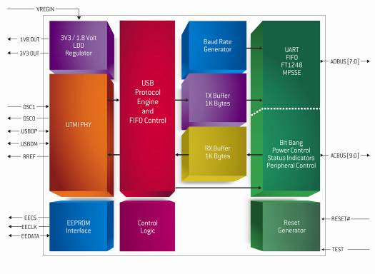
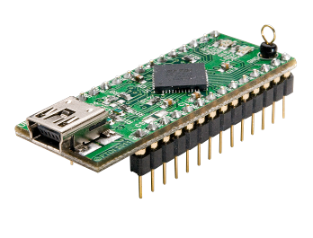
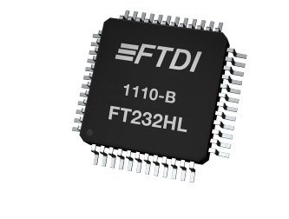

About FTDI
Future Technology Devices International (FTDI) specialises in the design and supply of silicon and software solutions for the Universal Serial Bus (USB). FTDI offers a simple route to USB migration by combining easy-to-implement IC devices with proven, ready-to-use, royalty-free USB firmware and driver software. The company’s single and multi-channel USB peripheral devices come with an easy-to-use UART or FIFO interface. These popular devices can be used in legacy USB-to-RS232/RS422 converter applications or to quickly interface an MCU, PLD, or FPGA to USB. A wide range of evaluation kits and modules are available to evaluate FTDI’s silicon prior to design-in. Vinculum is FTDI’s brand name for a range of USB Host/Slave controller ICs that provide easy implementation of USB Host controller functionality within products and use FTDI's tried and tested firmware to significantly reduce development costs and time to market. FTDI is a fables semiconductor company headquartered in Glasgow, UK with R&D centres in Glasgow and Singapore and has regional sales offices in Oregon, USA, Shanghai, China and Taipei, Taiwan.
More information is available at http://www.ftdichip.com
Regional sales offices and distributor lists are available http://www.ftdichip.com/FTSalesNetwork.htm

For further information and reader enquiries:
Erika Leishman
Future Technology Devices International Limited
Unit 1, 2 Seaward Place, Centurion Business Park, Glasgow, G41 1HH, UK
Tel: +44 (0) 141 429 2777 Fax: +44 (0) 141 429 2758 E-mail: erika.leishman@ftdichip.com

Issued by:
Mike Green
Pinnacle Marketing Communications Ltd
Prosperity House, Dawlish Drive, Pinner, Middsx, HA5 5LN
Tel: +44 (0)20 84296543 E-mail: m.green@pinnaclemarcom.com Web: www.pinnacle-marketing.com

Ref: FTDIPR4 FT232H

